We’ve look to SVM using soft margin function, now we look into it via Loss minimization function

Why are we doing this, because as we seen in logistic and linear regression, just changing the loss function would give us the new model, so similarly in SVM there is a loss called **hinge loss**, so we just replace the loss with hinge loss and we get SVM.

**What is hinge loss:**

Graph for hinge loss is shown below, on x axis we have z_i as y_i * ((W_T * x_i) + b), and on y we have hinge loss.

So as we can see that hinge loss become 0 when z_i >= 1.

Hinge loss is not differentiable at z_i = 1, because it’s not smooth here. Even though it’s continuous.

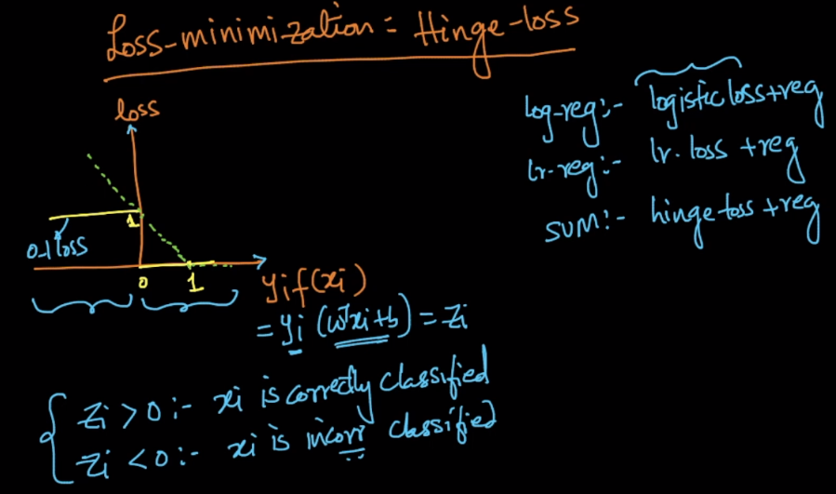

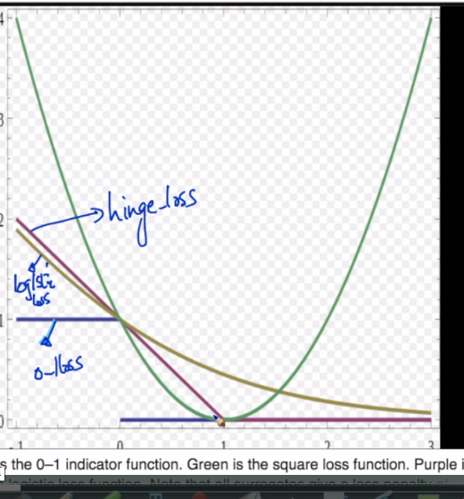

Now since we know that

Z_i > 0 : if xi is correctly classified

And Z_i < 0 : if xi is incorrectly classified.

Now what hinge loss says that if z_i >= 1 loss become 0 and

For z_i < 1, loss is 1 - z_i.

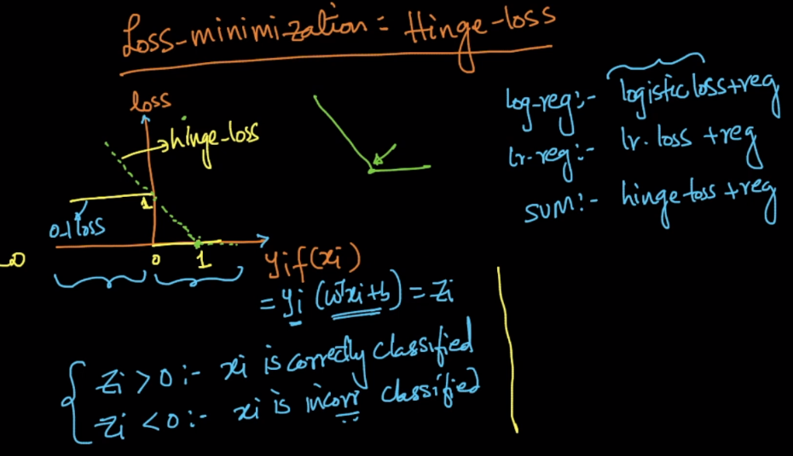

This hinge loss in one line can be written as **max(0, 1-z_i)**

Why it can be written like this?

Case 1: when z_i >= 1, that means it’s correctly classified and 1-z_i will be –ve value and since 0 > -ve and loss for correctly classified should be 0, therefore it’s true for z_i >= 1.

Case 2: when z_i < 1, that means 1-z_i > 0, therefore here there would be some loss.

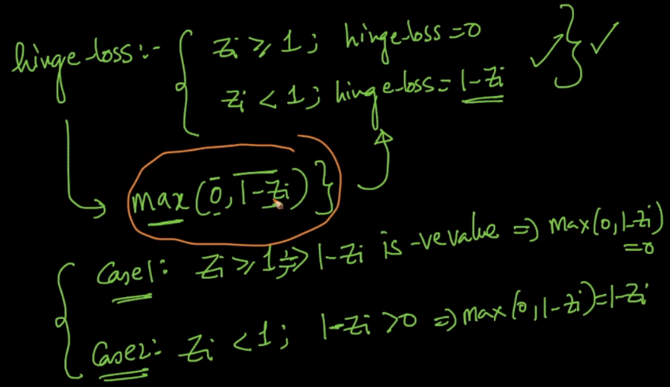

**Geometric representation of hinge loss:**

Let’s say there is +ve point below pie-, so it’s distance from pie+ will be.

d_j = 1 - y_i * ((W_T * x_i) + b) = 1 – z_i.

why for that +ve point lie below pie-, y_i * ((W_T * x_i) + b) will be -1.5, and

therefore d_j = 1 - 1.5 =2.5.

And as we know zeta = d_j.

So therefore we can say when point is misclassified that zeta = 1 – z_i

**Here zeta is loss, as we can see that zeta is similar to loss we get in hinge loss for incorrectly classified points.**

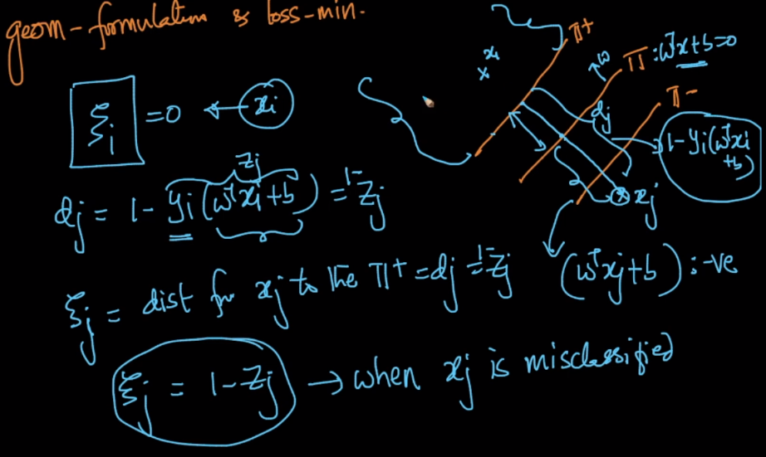

**Let’s look Soft margin SVM and Loss minimization of SVM together.**

* As we can see that in margin SVM, right is loss and in Loss min, left is loss.

Here in margin SVM C is associated with loss but there is nothing in loss of loss min.

* Left of margin SVM is regularization , right loss min, is regularization.

There is regularization term lambda associated in loss min, and there is nothing in loss min, regularization.

In margin SVM:

* C increases, become overfit
* C decreases, become underfit

In loss minimization

* Lambda increases, become underfit.
* Lambda decreases, become overfit.

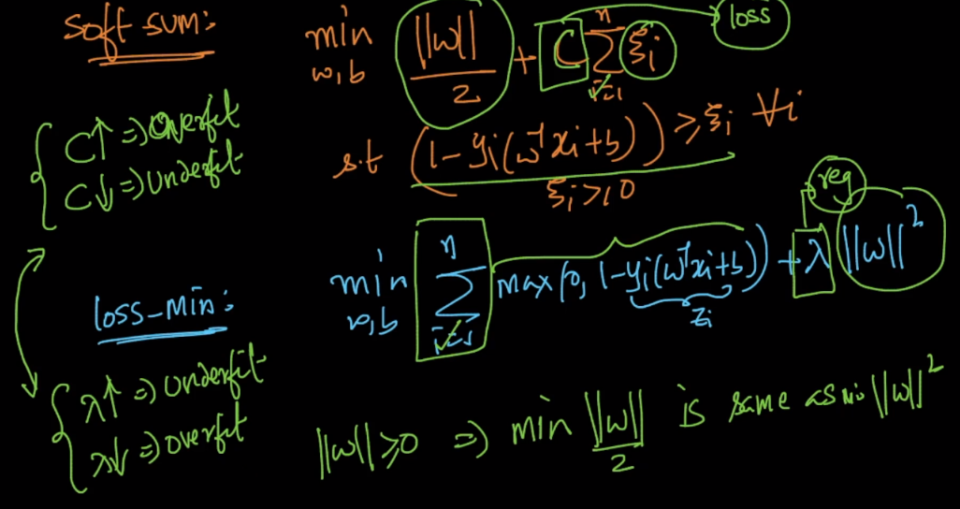

Following are the corrections in images

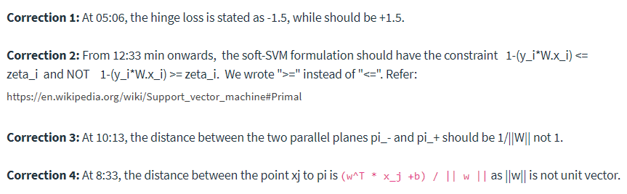

<https://medium.com/@ashwanibhardwajcodevita16/from-zero-to-hero-in-depth-support-vector-machine-264931a1e135>